I am trying to make an app which can define points on curve Y= a+bX

MainActivity.java

NOTE: there is no syntax error or runtime error

package com.hacker.prakharsharma.curvefitting;

import android.support.v7.app.AppCompatActivity;

import android.os.Bundle;

import android.view.Menu;

import android.view.MenuItem;

import android.view.View;

import android.widget.Button;

import android.widget.TextView;

public class MainActivity extends AppCompatActivity implements View.OnClickListener {

private int[] x={R.id.x1,R.id.x2,R.id.x3,R.id.x4,R.id.x5}; //x coordinates

private int[] y={R.id.y1,R.id.y2,R.id.y3,R.id.y4,R.id.y5}; // y coordinates

private TextView t1,t2,t3,t4,rsq,res;

T1- summation X

T2- summation X2

T3-summation Y

T4-summation XY

Error or Rsq- calc the least square error

Res= show well defined equation

private Button calc;

@Override

protected void onCreate(Bundle savedInstanceState) {

super.onCreate(savedInstanceState);

setContentView(R.layout.activity_main);

start();

}

private void start() {

t1 = (TextView) findViewById(R.id.t1r);

t2 = (TextView) findViewById(R.id.t2r);

t3 = (TextView) findViewById(R.id.t3r);

t4 = (TextView) findViewById(R.id.t4r);

rsq = (TextView) findViewById(R.id.err);

res = (TextView) findViewById(R.id.eqn);

calc = (Button) findViewById(R.id.calc);

calc.setOnClickListener(this);

}

@Override

public void onClick(View v) {

int i,tot1,tot2,tot3,tot4,error,a,b;

tot1=tot2=tot3=tot4=error=a=b=0;

for(i=0;i<5;i++)

{

tot1=tot1+x[i];

tot2=tot2+x[i]*x[i];

tot3=tot3+y[i];

tot4=tot4+x[i]*y[i];

}

b=(tot1*tot3-5*tot4)/(tot1*tot1-5*tot2);

a=(tot3-b*tot1)/5;

t1.setText(String.valueOf(tot1));

t2.setText(String.valueOf(tot2));

t3.setText(String.valueOf(tot3));

t4.setText(String.valueOf(tot4));

for(i=0;i<5;i++)

{

error=error+(y[i]-a-b*x[i])*(y[i]-a-b*x[i]);

}

rsq.setText(String.valueOf(error));

res.setText("Y= ");

res.append(String.valueOf(a));

res.append("+");

res.append(String.valueOf(b));

res.append("X");

}

}

Activity_main.xml

Note:there is no error in layout

<RelativeLayout xmlns:android="http://schemas.android.com/apk/res/android"

xmlns:tools="http://schemas.android.com/tools" android:layout_width="match_parent"

android:layout_height="match_parent" android:paddingLeft="@dimen/activity_horizontal_margin"

android:paddingRight="@dimen/activity_horizontal_margin"

android:paddingTop="@dimen/activity_vertical_margin"

android:paddingBottom="@dimen/activity_vertical_margin" tools:context=".MainActivity"

android:id="@+id/f1"

android:background="#0eff26">

<TextView

android:layout_width="wrap_content"

android:layout_height="wrap_content"

android:textAppearance="?android:attr/textAppearanceLarge"

android:text="Type: Y=a+bX"

android:id="@+id/banner"

android:layout_alignParentTop="true"

android:layout_centerHorizontal="true"

android:textColor="#ff250c" />

<TextView

android:layout_width="wrap_content"

android:layout_height="wrap_content"

android:textAppearance="?android:attr/textAppearanceSmall"

android:text="X"

android:id="@+id/textView"

android:layout_below="@+id/banner"

android:layout_alignParentLeft="true"

android:layout_alignParentStart="true"

android:layout_marginLeft="54dp"

android:layout_marginStart="54dp"

android:layout_marginTop="32dp"

android:textColor="#1e55ff" />

<EditText

android:layout_width="wrap_content"

android:layout_height="wrap_content"

android:id="@+id/x1"

android:layout_below="@+id/textView"

android:layout_alignParentLeft="true"

android:layout_alignParentStart="true"

android:layout_toLeftOf="@+id/banner"

android:layout_toStartOf="@+id/banner"

android:text="0" />

<EditText

android:layout_width="wrap_content"

android:layout_height="wrap_content"

android:id="@+id/x2"

android:layout_below="@+id/x1"

android:layout_alignRight="@+id/x1"

android:layout_alignEnd="@+id/x1"

android:layout_alignParentLeft="true"

android:layout_alignParentStart="true"

android:text="0" />

<EditText

android:layout_width="wrap_content"

android:layout_height="wrap_content"

android:id="@+id/x3"

android:layout_below="@+id/x2"

android:layout_alignRight="@+id/x2"

android:layout_alignEnd="@+id/x2"

android:layout_alignParentLeft="true"

android:layout_alignParentStart="true"

android:text="0" />

<EditText

android:layout_width="wrap_content"

android:layout_height="wrap_content"

android:id="@+id/x4"

android:layout_below="@+id/x3"

android:layout_alignParentLeft="true"

android:layout_alignParentStart="true"

android:layout_alignRight="@+id/x3"

android:layout_alignEnd="@+id/x3"

android:text="0" />

<EditText

android:layout_width="wrap_content"

android:layout_height="wrap_content"

android:id="@+id/x5"

android:layout_below="@+id/x4"

android:layout_alignRight="@+id/x3"

android:layout_alignEnd="@+id/x3"

android:layout_alignParentLeft="true"

android:layout_alignParentStart="true"

android:text="0" />

<EditText

android:layout_width="wrap_content"

android:layout_height="wrap_content"

android:id="@+id/y1"

android:layout_above="@+id/x2"

android:layout_alignParentRight="true"

android:layout_alignParentEnd="true"

android:layout_toRightOf="@+id/banner"

android:layout_toEndOf="@+id/banner"

android:text="0" />

<EditText

android:layout_width="wrap_content"

android:layout_height="wrap_content"

android:id="@+id/y2"

android:layout_below="@+id/y1"

android:layout_alignLeft="@+id/y1"

android:layout_alignStart="@+id/y1"

android:layout_alignParentRight="true"

android:layout_alignParentEnd="true"

android:text="0" />

<EditText

android:layout_width="wrap_content"

android:layout_height="wrap_content"

android:id="@+id/y3"

android:layout_alignBottom="@+id/x3"

android:layout_alignLeft="@+id/y2"

android:layout_alignStart="@+id/y2"

android:layout_alignParentRight="true"

android:layout_alignParentEnd="true"

android:text="0" />

<EditText

android:layout_width="wrap_content"

android:layout_height="wrap_content"

android:id="@+id/y4"

android:layout_alignBottom="@+id/x4"

android:layout_alignLeft="@+id/y3"

android:layout_alignStart="@+id/y3"

android:layout_alignParentRight="true"

android:layout_alignParentEnd="true"

android:text="0" />

<EditText

android:layout_width="wrap_content"

android:layout_height="wrap_content"

android:id="@+id/y5"

android:layout_below="@+id/y4"

android:layout_alignLeft="@+id/y4"

android:layout_alignStart="@+id/y4"

android:layout_alignParentRight="true"

android:layout_alignParentEnd="true"

android:text="0" />

<TextView

android:layout_width="wrap_content"

android:layout_height="wrap_content"

android:textAppearance="?android:attr/textAppearanceSmall"

android:text="Y"

android:id="@+id/textView2"

android:layout_alignTop="@+id/textView"

android:layout_alignLeft="@+id/y1"

android:layout_alignStart="@+id/y1"

android:layout_toLeftOf="@+id/y1"

android:layout_toStartOf="@+id/y1" />

<TextView

android:layout_width="wrap_content"

android:layout_height="wrap_content"

android:textAppearance="?android:attr/textAppearanceSmall"

android:text="Y"

android:id="@+id/textView3"

android:layout_above="@+id/y1"

android:layout_toRightOf="@+id/textView2"

android:layout_toEndOf="@+id/textView2"

android:layout_marginLeft="29dp"

android:layout_marginStart="29dp"

android:textColor="#1e55ff" />

<TextView

android:layout_width="wrap_content"

android:layout_height="wrap_content"

android:textAppearance="?android:attr/textAppearanceMedium"

android:text="∑ X"

android:id="@+id/t1"

android:layout_below="@+id/x5"

android:layout_alignParentLeft="true"

android:layout_alignParentStart="true"

android:layout_marginTop="38dp"

android:textColor="#1e55ff" />

<TextView

android:layout_width="wrap_content"

android:layout_height="wrap_content"

android:textAppearance="?android:attr/textAppearanceMedium"

android:text="∑ X2"

android:id="@+id/t2"

android:layout_below="@+id/t1"

android:layout_alignParentLeft="true"

android:layout_alignParentStart="true"

android:textColor="#1e55ff" />

<TextView

android:layout_width="wrap_content"

android:layout_height="wrap_content"

android:textAppearance="?android:attr/textAppearanceMedium"

android:text="∑ Y"

android:id="@+id/t3"

android:layout_below="@+id/t2"

android:layout_alignParentLeft="true"

android:layout_alignParentStart="true"

android:textColor="#1e55ff" />

<TextView

android:layout_width="wrap_content"

android:layout_height="wrap_content"

android:textAppearance="?android:attr/textAppearanceMedium"

android:text="∑ XY"

android:id="@+id/t4"

android:layout_below="@+id/t3"

android:layout_alignParentLeft="true"

android:layout_alignParentStart="true"

android:textColor="#1e55ff" />

<TextView

android:layout_width="wrap_content"

android:layout_height="wrap_content"

android:textAppearance="?android:attr/textAppearanceMedium"

android:text="Error"

android:id="@+id/rsq"

android:layout_below="@+id/t4"

android:layout_alignLeft="@+id/t4"

android:layout_alignStart="@+id/t4"

android:textColor="#1e55ff" />

<TextView

android:layout_width="wrap_content"

android:layout_height="wrap_content"

android:textAppearance="?android:attr/textAppearanceMedium"

android:text="Equation"

android:id="@+id/res"

android:layout_below="@+id/rsq"

android:layout_alignParentLeft="true"

android:layout_alignParentStart="true"

android:textColor="#1e55ff" />

<TextView

android:layout_width="wrap_content"

android:layout_height="wrap_content"

android:textAppearance="?android:attr/textAppearanceMedium"

android:text="Waiting"

android:id="@+id/t1r"

android:layout_above="@+id/t2"

android:layout_alignParentRight="true"

android:layout_alignParentEnd="true" />

<TextView

android:layout_width="wrap_content"

android:layout_height="wrap_content"

android:textAppearance="?android:attr/textAppearanceMedium"

android:text="Waiting"

android:id="@+id/t2r"

android:layout_below="@+id/t1r"

android:layout_alignParentRight="true"

android:layout_alignParentEnd="true" />

<TextView

android:layout_width="wrap_content"

android:layout_height="wrap_content"

android:textAppearance="?android:attr/textAppearanceMedium"

android:text="Waiting"

android:id="@+id/t3r"

android:layout_below="@+id/t2r"

android:layout_alignParentRight="true"

android:layout_alignParentEnd="true" />

<TextView

android:layout_width="wrap_content"

android:layout_height="wrap_content"

android:textAppearance="?android:attr/textAppearanceMedium"

android:text="Waiting"

android:id="@+id/t4r"

android:layout_below="@+id/t3r"

android:layout_alignParentRight="true"

android:layout_alignParentEnd="true" />

<TextView

android:layout_width="wrap_content"

android:layout_height="wrap_content"

android:textAppearance="?android:attr/textAppearanceMedium"

android:text="Waiting"

android:id="@+id/err"

android:layout_above="@+id/res"

android:layout_alignParentRight="true"

android:layout_alignParentEnd="true" />

<TextView

android:layout_width="wrap_content"

android:layout_height="wrap_content"

android:textAppearance="?android:attr/textAppearanceMedium"

android:text="a+bX"

android:id="@+id/eqn"

android:layout_below="@+id/err"

android:layout_alignParentRight="true"

android:layout_alignParentEnd="true" />

<Button

android:layout_width="wrap_content"

android:layout_height="wrap_content"

android:text="Calculate"

android:id="@+id/calc"

android:layout_above="@+id/t1r"

android:layout_centerHorizontal="true" />

<TextView

android:layout_width="wrap_content"

android:layout_height="wrap_content"

android:textAppearance="?android:attr/textAppearanceMedium"

android:text="By Prakhar Sharma"

android:id="@+id/textView4"

android:layout_alignParentBottom="true"

android:layout_alignParentRight="true"

android:layout_alignParentEnd="true"

android:textColor="#3661ff" />

</RelativeLayout>



When I put some preknown values it shows wrong result

I tried Debugging too

Even If the input section is empty it shows same result

Looks like the answer is predetermined

I have sent an compiled apk file too

Since whatsapp cannot send apks so I renamed it to curvefitting.apk.pdf

Snap as it Opens

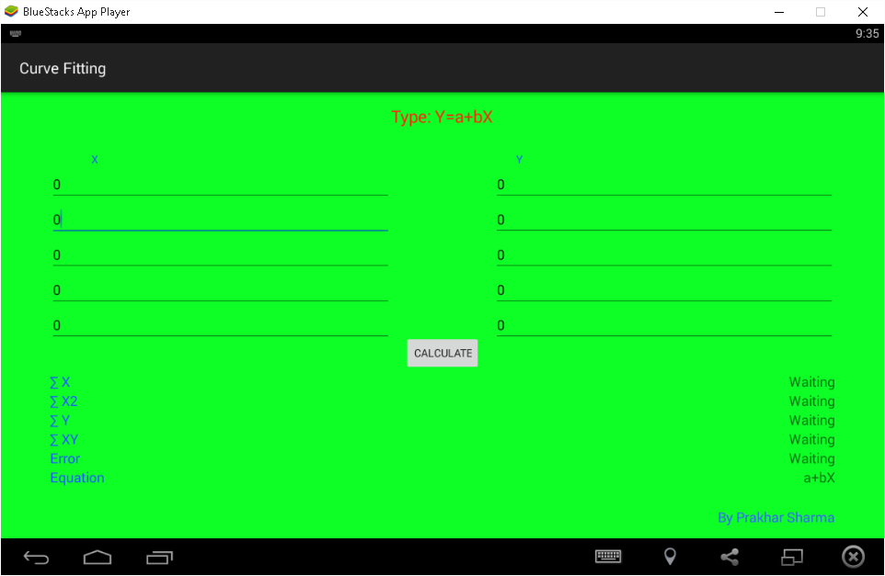

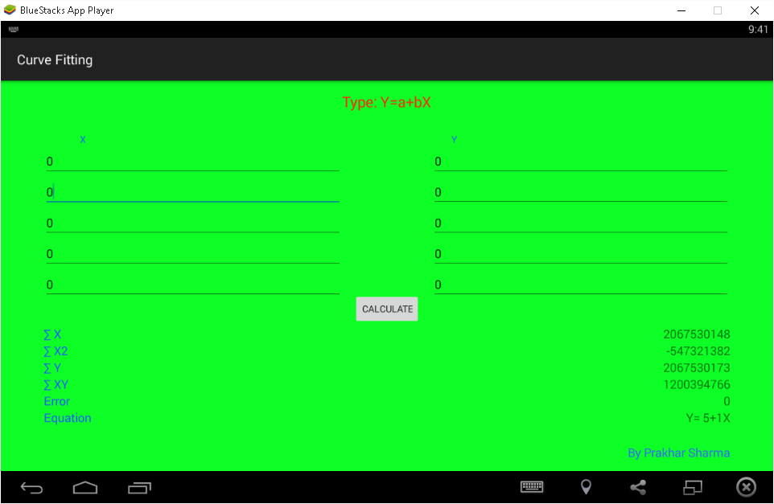

Same result every time.

May be wrong initialization